

300 Volt

Electrophoresis Power Supply

Catalog Number

E0303 110Volt

E303-230V 230Volt



Table of Contents
FCC Warning | 3
Safety Information | 3
Package Contents | 4
Product Specifications | 5
Overview | 6
Description of Buttons and Switches | 6
Getting Started | 7
Important Guidelines | 8
Operation | 8
Choosing Limiting Parameter Settings | 9
Troubleshooting | 11
Repair and Maintenance of 300V Power Supply | 12
APPENDIX | 13
Ohm’s Law Conversions | 13
Flowchart | 14
Technical Service | 15
Warranty | 15
Equipment Disposal | 16
Warning

Federal Communications Commission Advisory
This equipment has been tested and found to comply with the limits for a Class A digital device, pursuant to part 15 of the FCC rules. These limits are designed to provide reasonable protection against harmful interference when the equipment is operated in a commercial environment. This equipment generates, uses, and can radiate radio frequency energy and, if not installed and used in accordance with the instruction manual, may cause harmful interference to radio communications. Operation of this equipment in a residential area is likely to cause harmful interference in which case the user will be required to correct the interference at their expense. Changes or modifications not expressly approved by the party responsible for compliance could void the user’s authority to operate the equipment.

Safety Information

Avoiding Electrical Shock
The ENDURO 300 Volt Power Supply produces an output of up to 300 volts which are electrically isolated from ground to reduce the risk of electrical shock to the user. Please follow the guidelines below, and read this manual in it’s entirety to ensure safe operation of the unit.
The ENDURO 300 Volt Power Supply has been designed for use with electrophoresis gel box systems with shielded banana plugs thus minimizing any potential shock hazard to the user. Always use gel box systems that are compatible with the Power Supply, have been designed for your specific applications, and are suitable for the voltage and current range of the Power Supply. Always use gel box systems that have safety lids to prevent accidental electric shocks to the user. Labnet International recommends against the use of gel box systems and/or power leads that have unshielded banana plugs.


To avoid electrical shock:

1. NEVER connect or disconnect wire leads from the power jacks when the red indicator light at the Start/Stop key is on or when “RUNNING” is displayed on the screen.
2. WAIT at least 5 seconds after stopping a run before handling output leads or connected apparatus.
3. ALWAYS make sure that hands, work area, and instruments are clean and dry before making any connections or operating the power supply.
4. ONLY connect the power supply to a properly grounded AC outlet.

Avoiding Damage to the Instrument

1. For proper ventilation, leave at least 10 cm of space behind the instrument, and at least 5 cm of space on each side.
2. Do not operate the power supply in high humidity environments (> 95%), or where condensation may occur.
3. To avoid condensation after operating the power supply in a cold room, seal the unit in a plastic bag and allow at least 2 hours for the unit to equilibrate to room temperature before removing the bag and operating the unit.

Symbols


Used on the ENDURO 300 Volt Power Supply to indicate an area where a potential shock hazard may exist.

Package Contents
Component Quantity
ENDURO 300 Volt Power Supply 1 each
Instruction Manual 1 each
Extra Fuse 1 each
Power Cord 1 each
Warranty Card 1 each
Quick Reference Card 1 each

Upon Receiving the Instrument
Examine the unit carefully for any damage incurred during transit. Any damage claims must be filed with the carrier. The warranty does not cover in-transit damage.

To ensure safe, reliable operation, always operate the ENDURO 300 Volt Power Supply in accordance with the manufacturer’s instructions. Always wear protective gloves and safety glasses when working in a laboratory environment. See Safety Information and Warranty Information in this manual.

Product Specifications

300V Power Supply Specifications
Input Power (switchable) 110 VAC, 50-60 Hz
230 VAC, 50-60 Hz
Fuses One 4A/250V, one extra fuse is provided
Output power in watts 90 watts
Output voltage range 2~300V
Output current range 4~500 mA
Duration Limits Time ~99.99 hr/min
Terminal pairs 4 (4 positive voltage and 4 negative voltage)

Operating Modes
Constant Voltage 1V increment settings
Constant Current 1 mA increment settings
Crossover Automatic
Display type Backlit LCD Graphic type
Display size 53.64 x 15.64 mm (W x H)
Pause function Yes
Safety features No Load Detection
Load Change Detection
Overload Detection
Ground Leak Detection
Auto Restart
Stackable Yes
Housing material Flame retardant ABS
Housing size 200 x 290 x 70 mm (W x D x H)
Operating temp. 0°C-40°C
Environmental condition 85% RH, 75 KPa-106 Kpa, Altitude not to exceed 2000 meters
Weight 1.2 kg
Certifications CE; TUV; CUL
Warranty 3 years

Overview
The ENDURO 300 Volt Power Supply is a microprocessor-controlled power supply designed to meet most electrophoresis needs in a single, easy to use unit. The power supply is capable of running constant voltage / constant current applications concurrently. This instrument is ideal for DNA/RNA electrophoresis, SDS-PAGE, native PAGE, and second-dimension SDS-PAGE applications. With four sets of output jacks that can be used simultaneously, the ENDURO 300 Volt Power Supply is designed to efficiently handle multiple electrophoresis gel tanks and use a small amount of lab space. The ENDURO 300 Volt Power Supply offers two modes, Constant Voltage or Constant Current Mode. This manual describes the setup and operation of the ENDURO 300 Volt Power Supply including important information on safety and maintenance of the unit.

Description of Buttons and Switches

Front View of ENDURO 300 Volt Power Supply
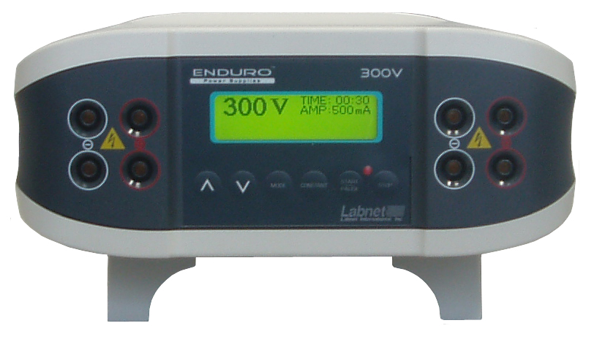
Control Buttons
LCD Display
Output Jacks

Rear View of ENDURO 300 Volt Power Supply
Power Inlet

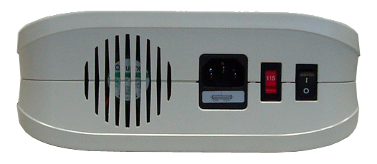
Voltage Selector
Power Switch
Fuse Drawer

Operational keys

Key Functions

STOP key: Used to stop operation from the Running Screen
STOP

START/PAUSE key: Used to start operation / temporarily interrupt power to an operation in progress without terminating electrophoresis and to resume power after pausing without resetting the timer.
START
PAUSE

CONSTANT key: Used to set up constant voltage or current values
CONSTANT

MODE key: Used to choose either Constant Voltage or Constant Current mode
MODE

Down Arrow key: Used to move cursor down between parameters and to decrease numeric values

Up Arrow key: Used to move cursor up between parameters and to increase numeric values

Getting Started

Installing the ENDURO 300 Volt Power Supply
1. Check the label located near the AC inlet to ensure that the unit is compatible with locally provided voltage.
2. Place the ENDURO 300 Volt Power Supply on a level laboratory bench. Keep the area around the power supply clear to ensure proper ventilation of the unit.
3. For your safety: Position the unit properly such that the On-Off switch and the AC inlet located on the rear of the unit are easily accessible.
4. Ensure the AC power switch is in the Off position.
5. Attach the power cord to the AC inlet. Use only properly grounded AC outlets and power cords.
6. Connect the leads from the electrophoresis unit; insert the red lead (+) into the red output jack, and the black lead (-) into the black output jack.

Important Guidelines
Important guidelines for operating the ENDURO 300 Volt Power Supply are provided in this section. We recommend that you carefully review these guidelines before operating the instrument.
 Important: For best results, do NOT use the ENDURO 300 Volt Power Supply at its maximum electrical load limits. Variations in buffer conditions can result in exceeding the power supply’s maximum voltage, current, or power output capacity and produce undesirable variations in electrophoretic separations.

General Operating Instructions
Follow the instructions below to operate the ENDURO 300 Volt Power Supply.
• Turn on the ENDURO 300 Volt Power Supply by pressing the power switch on the rear side of the instrument. Upon start-up, the Display Screen on the front of the instrument will illuminate.
• Use the START/PAUSE and STOP keys to switch on and off the power to the output jacks.

Recommendation
The duration of electrophoresis can be defined in time (hours/minutes). When using this or any electrophoresis product, we recommend that you adhere to the time protocols provided in protocol and application manuals.
Important: For best results, follow these important guidelines when running multiple gels and electrophoresis units concurrently.
• Avoid running samples with differing buffer salt concentrations at the same time.

Note: Variations in conductivity due to differences in buffer salt concentrations can affect the run of all the samples run at the same time.

Operation
The ENDURO 300 Volt Power Supply is designed to operate under two modes, Constant Voltage Mode or Constant Current Mode, depending upon your electrophoresis application.
Use the Constant Voltage / Current Mode for applications that require only one specific voltage limit or current limit during the entire duration of electrophoresis.

Display Screen
The Display Screen illuminates after turning on the power to your instrument and the factory default settings (or last settings used) will be displayed. You can choose the operational Mode (Constant Voltage or Constant Current Mode) by pressing the “constant” button.
• On the Display Screen:
• The chosen constant parameter (Voltage or Current) is displayed in bold on the left side of the display.
• The Timer is the first line on the right-top, and the non-constant value is displayed in the second line on the right side of the display screen.

Choosing Limiting Parameter Settings

The ENDURO 300 Volt Power Supply is capable of operating at limiting voltage, or limiting current. We recommend operating the 300Volt Power Supply at limiting voltage for most applications. See below for more details.

Voltage Limiting
For most electrophoresis methods, resistance increases during the run. Limiting the voltage provides the following advantages:
• The same voltage setting can be used regardless of the number or thickness of gels being processed.
• Current and power output decrease throughout the run, providing a greater margin of safety over time.

Current Limiting

Discontinuous buffer systems and, to a lesser extent, continuous systems increase resistance during the run. If you use the current limiting setting on the 300V Power Supply, the voltage will increase as resistance increases to satisfy Ohm’s law (V=IR). If no voltage limit is set and a local fault condition occurs, such as a poor connection, very high local resistance may cause the voltage to increase to the maximum capacity of the power supply. This may lead to local overheating and damage to the electrophoresis running tank or create unsafe conditions. When operating under constant current conditions, set a voltage limit on the power supply at or slightly above the maximum expected voltage.

Basic Constant Operation Protocol
The Constant Voltage and Constant Current Modes allow you to specify a voltage limit, and current limit to be used continuously during the entire duration of electrophoresis. Review the guidelines provided in this manual before starting electrophoresis.

A basic Constant Voltage / Current Mode operating procedure of the 300Volt Power Supply is provided on the below. We recommend reading the guidelines provided in this manual for best results before starting an operation.
1. Use the power switch on the rear side of the instrument to turn on the 300V Power Supply. The Display Screen will illuminate.
2. Press the CONSTANT key to select either Constant Voltage Operation or Constant Current Operation from the Display Screen.
3. Use the Up Arrow / Down Arrow keys to set either voltage (V) or current (mA) parameters to the appropriate values.
4. Press the MODE key to choose the TIME parameter, and use the Up Arrow / Down Arrow keys to set the duration (hours/minutes) of the electrophoresis run.
5. Press START/PAUSE key to start electrophoresis.
6. Press the START/PAUSE key again to temporarily interrupt power. The red “Run” LED will flash to indicate that the electrophoresis run is paused. Pressing the START/PAUSE key again will restart the electrophoresis run.
7. Press the STOP key to permanently stop the electrophoresis run (the timer will reset).
8. To change the limits (Voltage or Amperage) of the electrophoresis run in progress:
Press the Mode key. Enter the changes using the Up Arrow / Down Arrow keys, and then press START/PAUSE key once again to restart your operation.

Note: After stopping (using the STOP key) and restarting an operation, the timer resets and does not take into account the time that electrophoresis was in progress before it was stopped.

Troubleshooting
Review the information in the table below to troubleshoot operating problems.

Problem | Cause | Solution
The LCD screen remains blank and the fan does not run when the power is turned on | AC power cord is not connected | Check AC power cord connections at both ends. Use the correct cords.
 | The fuse has blown | Replace the fuse
Operation stops with alarm: The screen displays “NO LOAD” | Electrophoresis leads are not connected to the power supply or to the electrophoresis unit(s), or  there is a broken circuit in the electrophoresis cell | Check the connections to the power supply and on your electrophoresis cell to make sure the connection is intact; check condition of wires in electrophoresis unit. Close the circuit by reconnecting the cables. Press START/PAUSE to restart the run.
Operation stops with alarm: The screen displays “NO LOAD” | High resistance due to tape left on a pre-cast gel, incorrect buffer concentration, or incorrect buffer volumes in the electrophoresis cell | Correct the condition by making sure the tape is removed from the pre-cast gel, buffers are prepared  correctly, and the recommended volume of buffer is added to the electrophoresis unit.
Operation stops with alarm: The screen displays “NO LOAD” | High voltage application is set to run on a very low current | DISABLE No Load alarm on the Display Screen
Operation stops with alarm: Display shows “OVER VOLTAGE” | Circuit is interrupted | • Verify that the running buffer is correct.  • Verify the all cables are attached correctly  • Turn the Power switch off and on again; restart application.  • If you cannot restart the instrument, turn off the power, disconnect the power cord from the outlet, and contact Technical Service.
Operation stops with alarm: Display shows“LEAKAGE” | Ground leak detected during run | Check the electrophoresis system for improper grounding. Restart the power supply by turning the Power switch off and on.
Operation stops with alarm:  Display shows “OVER TEMP” | Power supply is overheating | • Turn off power supply. Check for sufficient airflow around the power supply fan. After cooling down, restart the power supply by turning the Power switch to the on position.  • If you cannot restart the  instrument, turn off the power, disconnect the power cord from the outlet, and contact Technical Service.
Repair and Maintenance of 300V Power Supply
The ENDURO 300 Volt Power Supply requires no periodic maintenance program with the exception of an occasional dry wipe-down of the instrument.

Encountering Problems
1. Check the troubleshooting section.
2. Contact Labnet’s Technical Service Department. Their contact information in your area can be found at www.labnetlink.com.
3. If the unit must be shipped back for repair, contact your distributor for a Return Authorization Number and shipping instructions. The unit will be repaired as quickly as possible and returned to you.

Replacing the Fuse
One extra fuse is supplied with the 300Volt Power Supply. For additional fuses, contact Labnet’s Technical Service department.
To replace the fuse:
1. Turn off the main power switch at the rear of the 300V Power Supply and detach the power cord.

2. Open the fuse compartment located inside the Power Entry Module by inserting a small flat blade screwdriver into the slot below the ON/OFF switch. Turn the screwdriver to gently pry open the fuse compartment.
Note: The fuse compartment will not open with the power cord in place.
3. Pull the fuse holder out of the compartment and inspect the fuse. If the fuse is burned or there is a break in the fuse element, replace the fuse with an identical type of fuse (4A/250V) as provided in the fuse holder (see figure below).
4. Place the fuse holder back into the compartment.
5. Snap the cover closed.

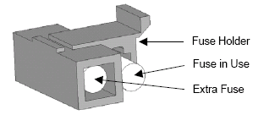
APPENDIX - Common Errors found with Electrophoresis Power Supplies

No load
- The electrophoresis system is not connected to the power leads, check the power leads
- The electrophoresis system has a short, the Pt wire is broken or the banana connectors are damaged
- Buffer concentration too low
- Buffer volume too low
- Short in power cord
- Current has dropped below acceptable rating (4 mA)

Short circuit
- Load exceeds 500 mA
- Blown fuse in the power supply
- Incorrect input voltage (check input voltage switch near power inlet)

Change in load
- Electrophoresis systems were added or removed during a run
- Buffer leaking in a connected system
- Excessive temperature increase
- Excessive buffer evaporation
- Loose connection in a connected system
- Amperage set to low

Change in constant mode
- Voltage changes to amperage
- Amperage set too low. Ceiling hit and constant mode changed from voltage to amperage. Increase amperage to 500 mA.
- Amperage changes to voltage
- Voltage set too low. Ceiling hit and constant mode changed from amperage to voltage. Increase voltage to 300 volts

The 300 volt system has automatic cross over, set voltage or amperage, and preset wattage. During the electrophoresis process only one parameter is limiting at a time. The limiting parameter, together with the conductivity in the electrophoresis system, and the values for the other parameters determine the maximum output.

Ohm’s Law Conversions
Electrophoresis is the migration of a charged particle under the influence of an electrical field. The power supply output parameters voltage, current, and power are related by the following two equations:
Voltage (V) = Current (I) x Resistance (R); (V=IR)
Power (W) = Current (I) x Voltage (V); (W=IV)

Resistance
Resistance of the assembled electrophoresis cell is dependent on the conductivity of the gel buffer, the thickness of the gel, and the number of gels being run. Although the resistance is determined by the gel system, the resistance can vary over the course of an electrophoretic separation.

Voltage
The velocity with which an ion moves in an electric field will vary in proportion to the field strength (volts per unit distance). The higher the voltage the faster an ion will move.

Current
Current is a function of the number of ions passing a given cross-section of the circuit at a given time. For a given gel/buffer system, at a given temperature, current will vary in proportion to the field strength (voltage) and/or cross-sectional area (number and/or thickness of the gels).

Power
The power in Watts, or the rate of heat generated by the system, is directly proportional to voltage and current (W=IV).

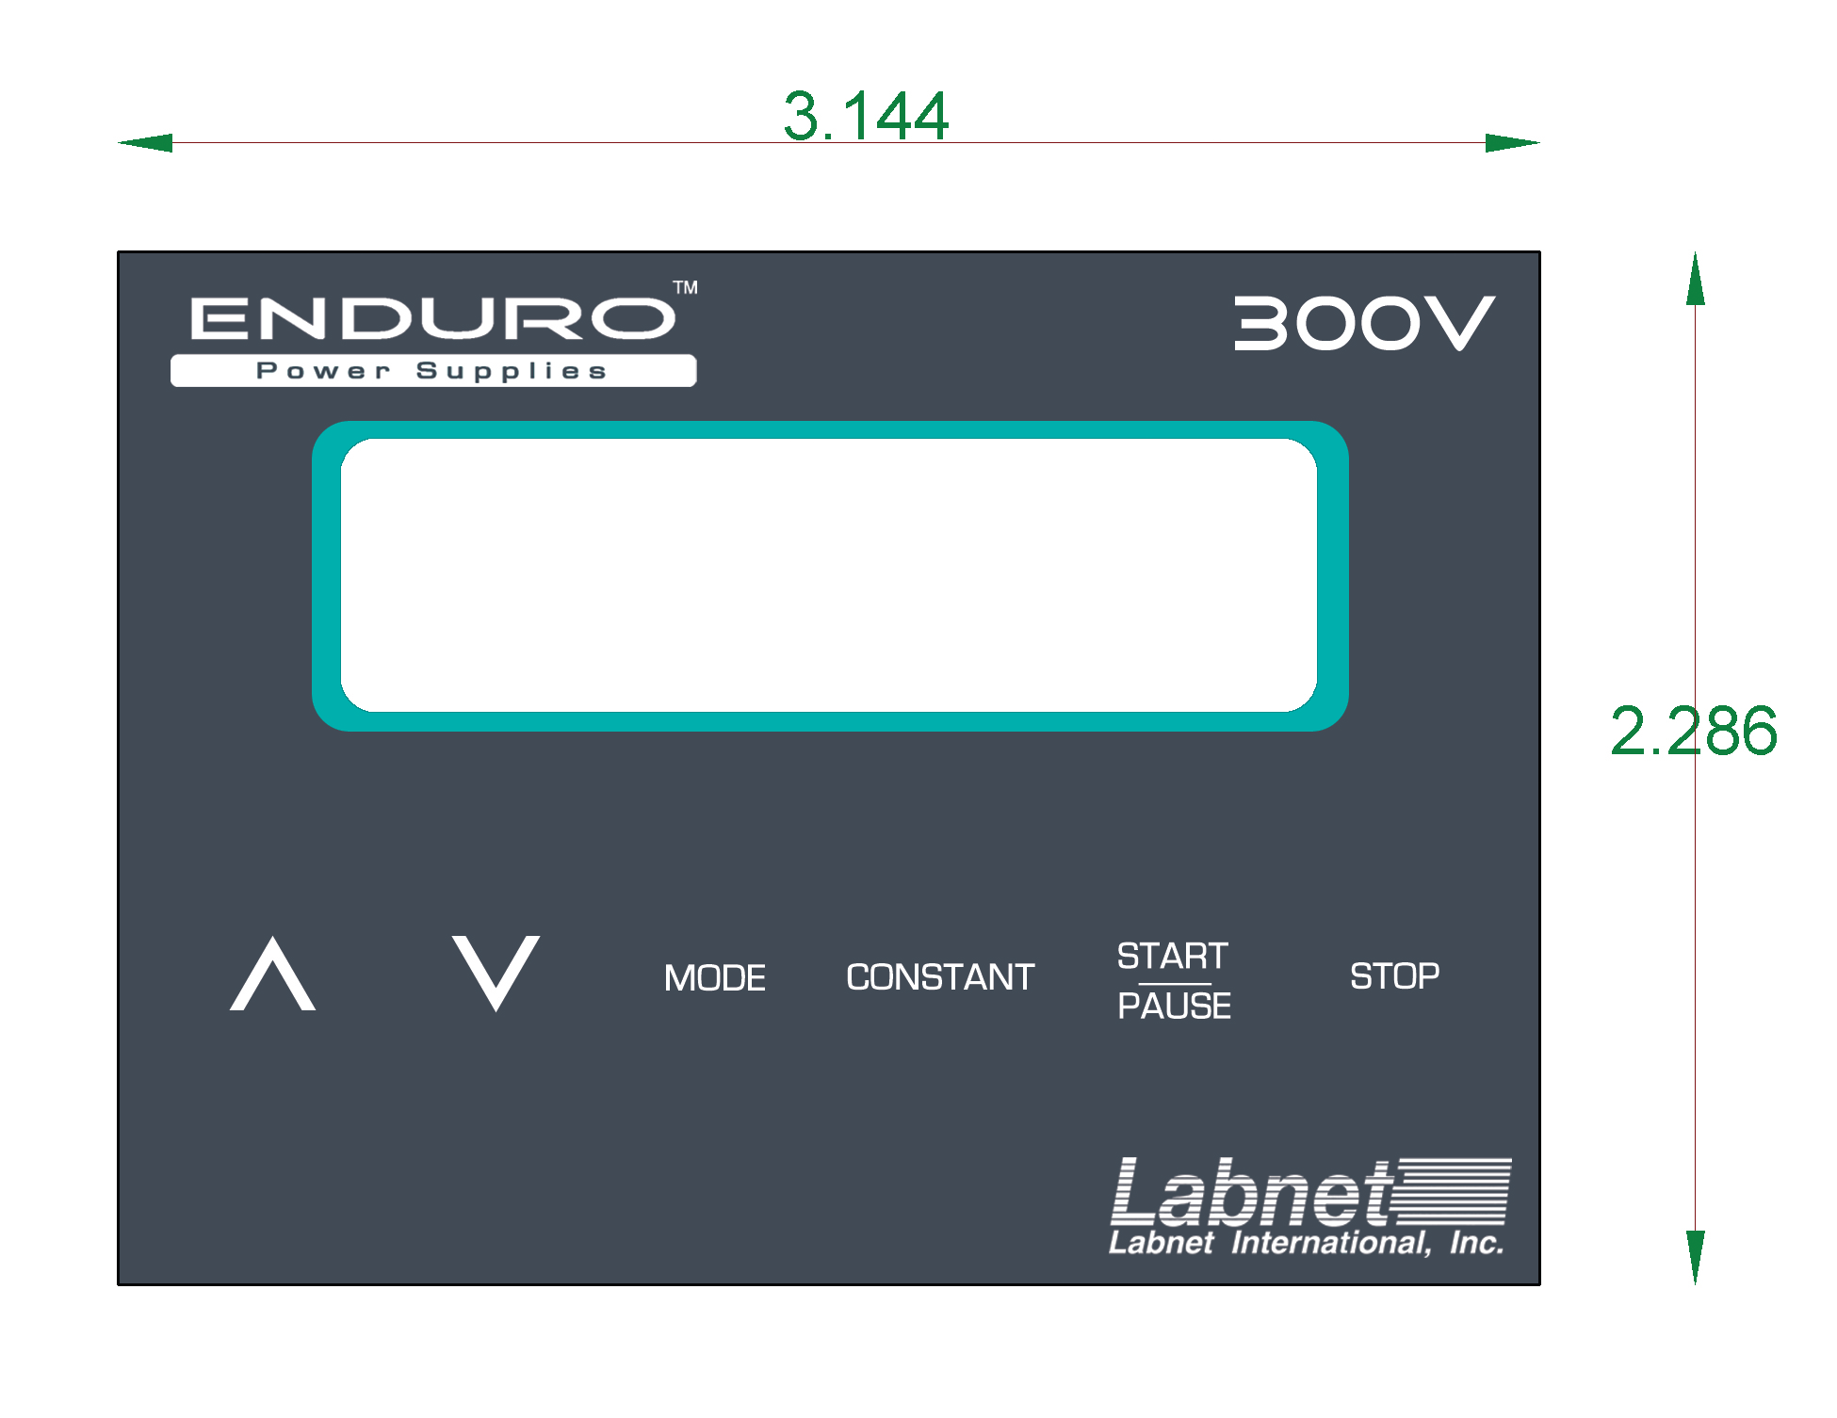
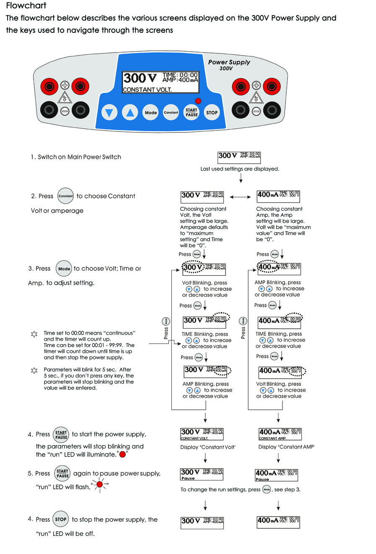

Technical Service

Web Resources
Visit the Labnet’s website at www.labnetlink.com for:
• Complete technical service contact information.
• Access to Labnet’s Online Catalog, and information about accessories and related products.
• Additional product information and special offers.
Contact Us For information or technical assistance contact your local Labnet Dealer or visit. www.labnetlink.com.

Legal Address of Manufacturer
United States | Europe
Labnet International | Labnet International
31 Mayfield Ave | 31 Mayfield Ave
Edison, NJ 08837 | Edison, NJ 08873
800-932-5000 | 732-417-0700
http://www.labnetlink.com | http://www.labnetlink.com

Warranty
Labnet International, Inc. warrants that this product will be free from defects in material and workmanship for a period of three (3) years from date of purchase. If a defect is present, Labnet International will, at its option, repair, replace, or refund the purchase price of this product at no charge to you, provided it is returned during the warranty period. This warranty does not apply if the product has been damaged by accident, abuse, misuse, or misapplication, or from ordinary wear and tear.
For your protection, items being returned must be insured against possible damage or loss. This warranty shall be limited to the replacement of defective products. IT IS EXPRESSLY AGREED THAT THIS WARRANTY WILL BE IN LIEU OF ALL WARRANTIES OF FITNESS AND IN LIEU OF THE WARRANTY OF MERCHANTABILITY.

For research use only. Not intended for any animal or human therapeutic or diagnostic use.

Equipment disposal



This equipment is marked with the crossed out wheeled bin symbol to indicate that this equipment must not be disposed of with unsorted waste.
Instead it's your responsibility to correctly dispose of your equipment at lifecycle -end by handling it over to an authorized facility for separate collection and recycling. It's also your responsibility to decontaminate the equipment in case of biological, chemical and/or radiological contamination, so as to protect from health hazards the persons involved in the disposal and recycling of the equipment.
For more information about where you can drop off your waste of equipment, please contact your local dealer from whom you originally purchased this equipment.

By doing so, you will help to conserve natural and environmental resources and you will ensure that your equipment is recycled in a manner that protects human health.

Thank you

